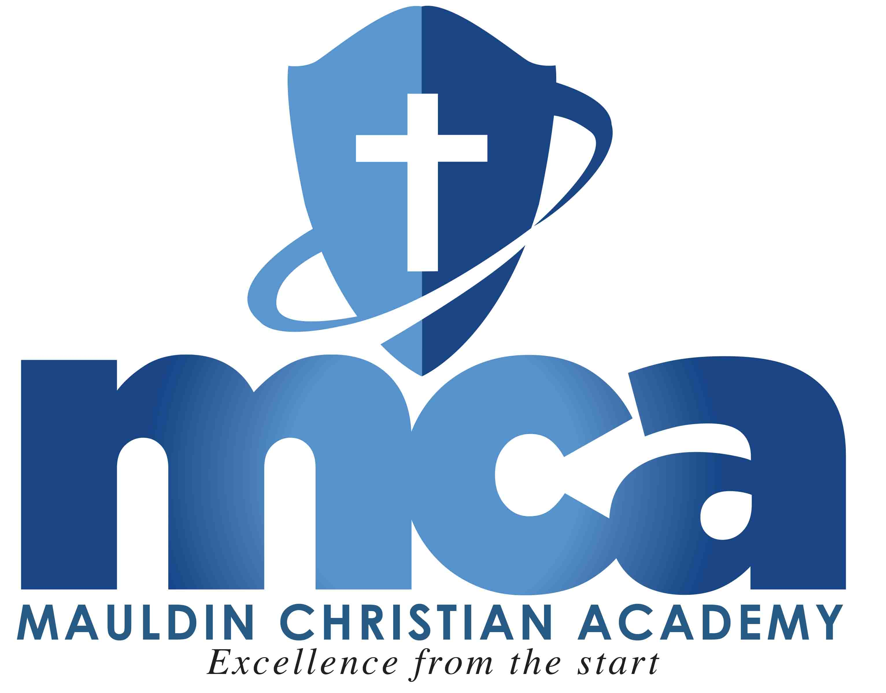
Mauldin Christian Academy
150 South Main Street
Mauldin SC 29662
864-288-1917 fax: 864-679-1623
Website: www.mauldinchristian.org

1st Grade Supply List 2018-2019 School Year
Mrs. Russell and Mrs. Vernon

2 packs of 24 count crayons
1 pack of 8 count classic color, large tip markers
2 twelve packs of yellow #2 pencils
2 large pink erasers
2 Dry erase markers – black or dark blue
4 large glue sticks
1 pair of blunt tip scissors
1 straight edge ruler (showing inches and centimeters)
1 plastic pencil box – 5”x 8” size with attached lid
1 pack of white copy paper
1 pack of white cardstock
3 boxes of Kleenex
1 standard size container of baby wipes

Please only label ruler, scissors and pencil box before bringing them to class. All other items will shared among the class, so please do not buy gender-specific items or label them. Thank you!

If you would like to bring in an old, oversized, button down shirt to be used during art class that would be acceptable and it would be kept at the Academy.

**It is highly recommended that Crayola brand products for crayons and markers be purchased due to their higher quality and longer lasting usage.

**You are encouraged to bring all supplies to Meet the Teacher Night on Thursday, August 16th at 6:30 p.m.**

