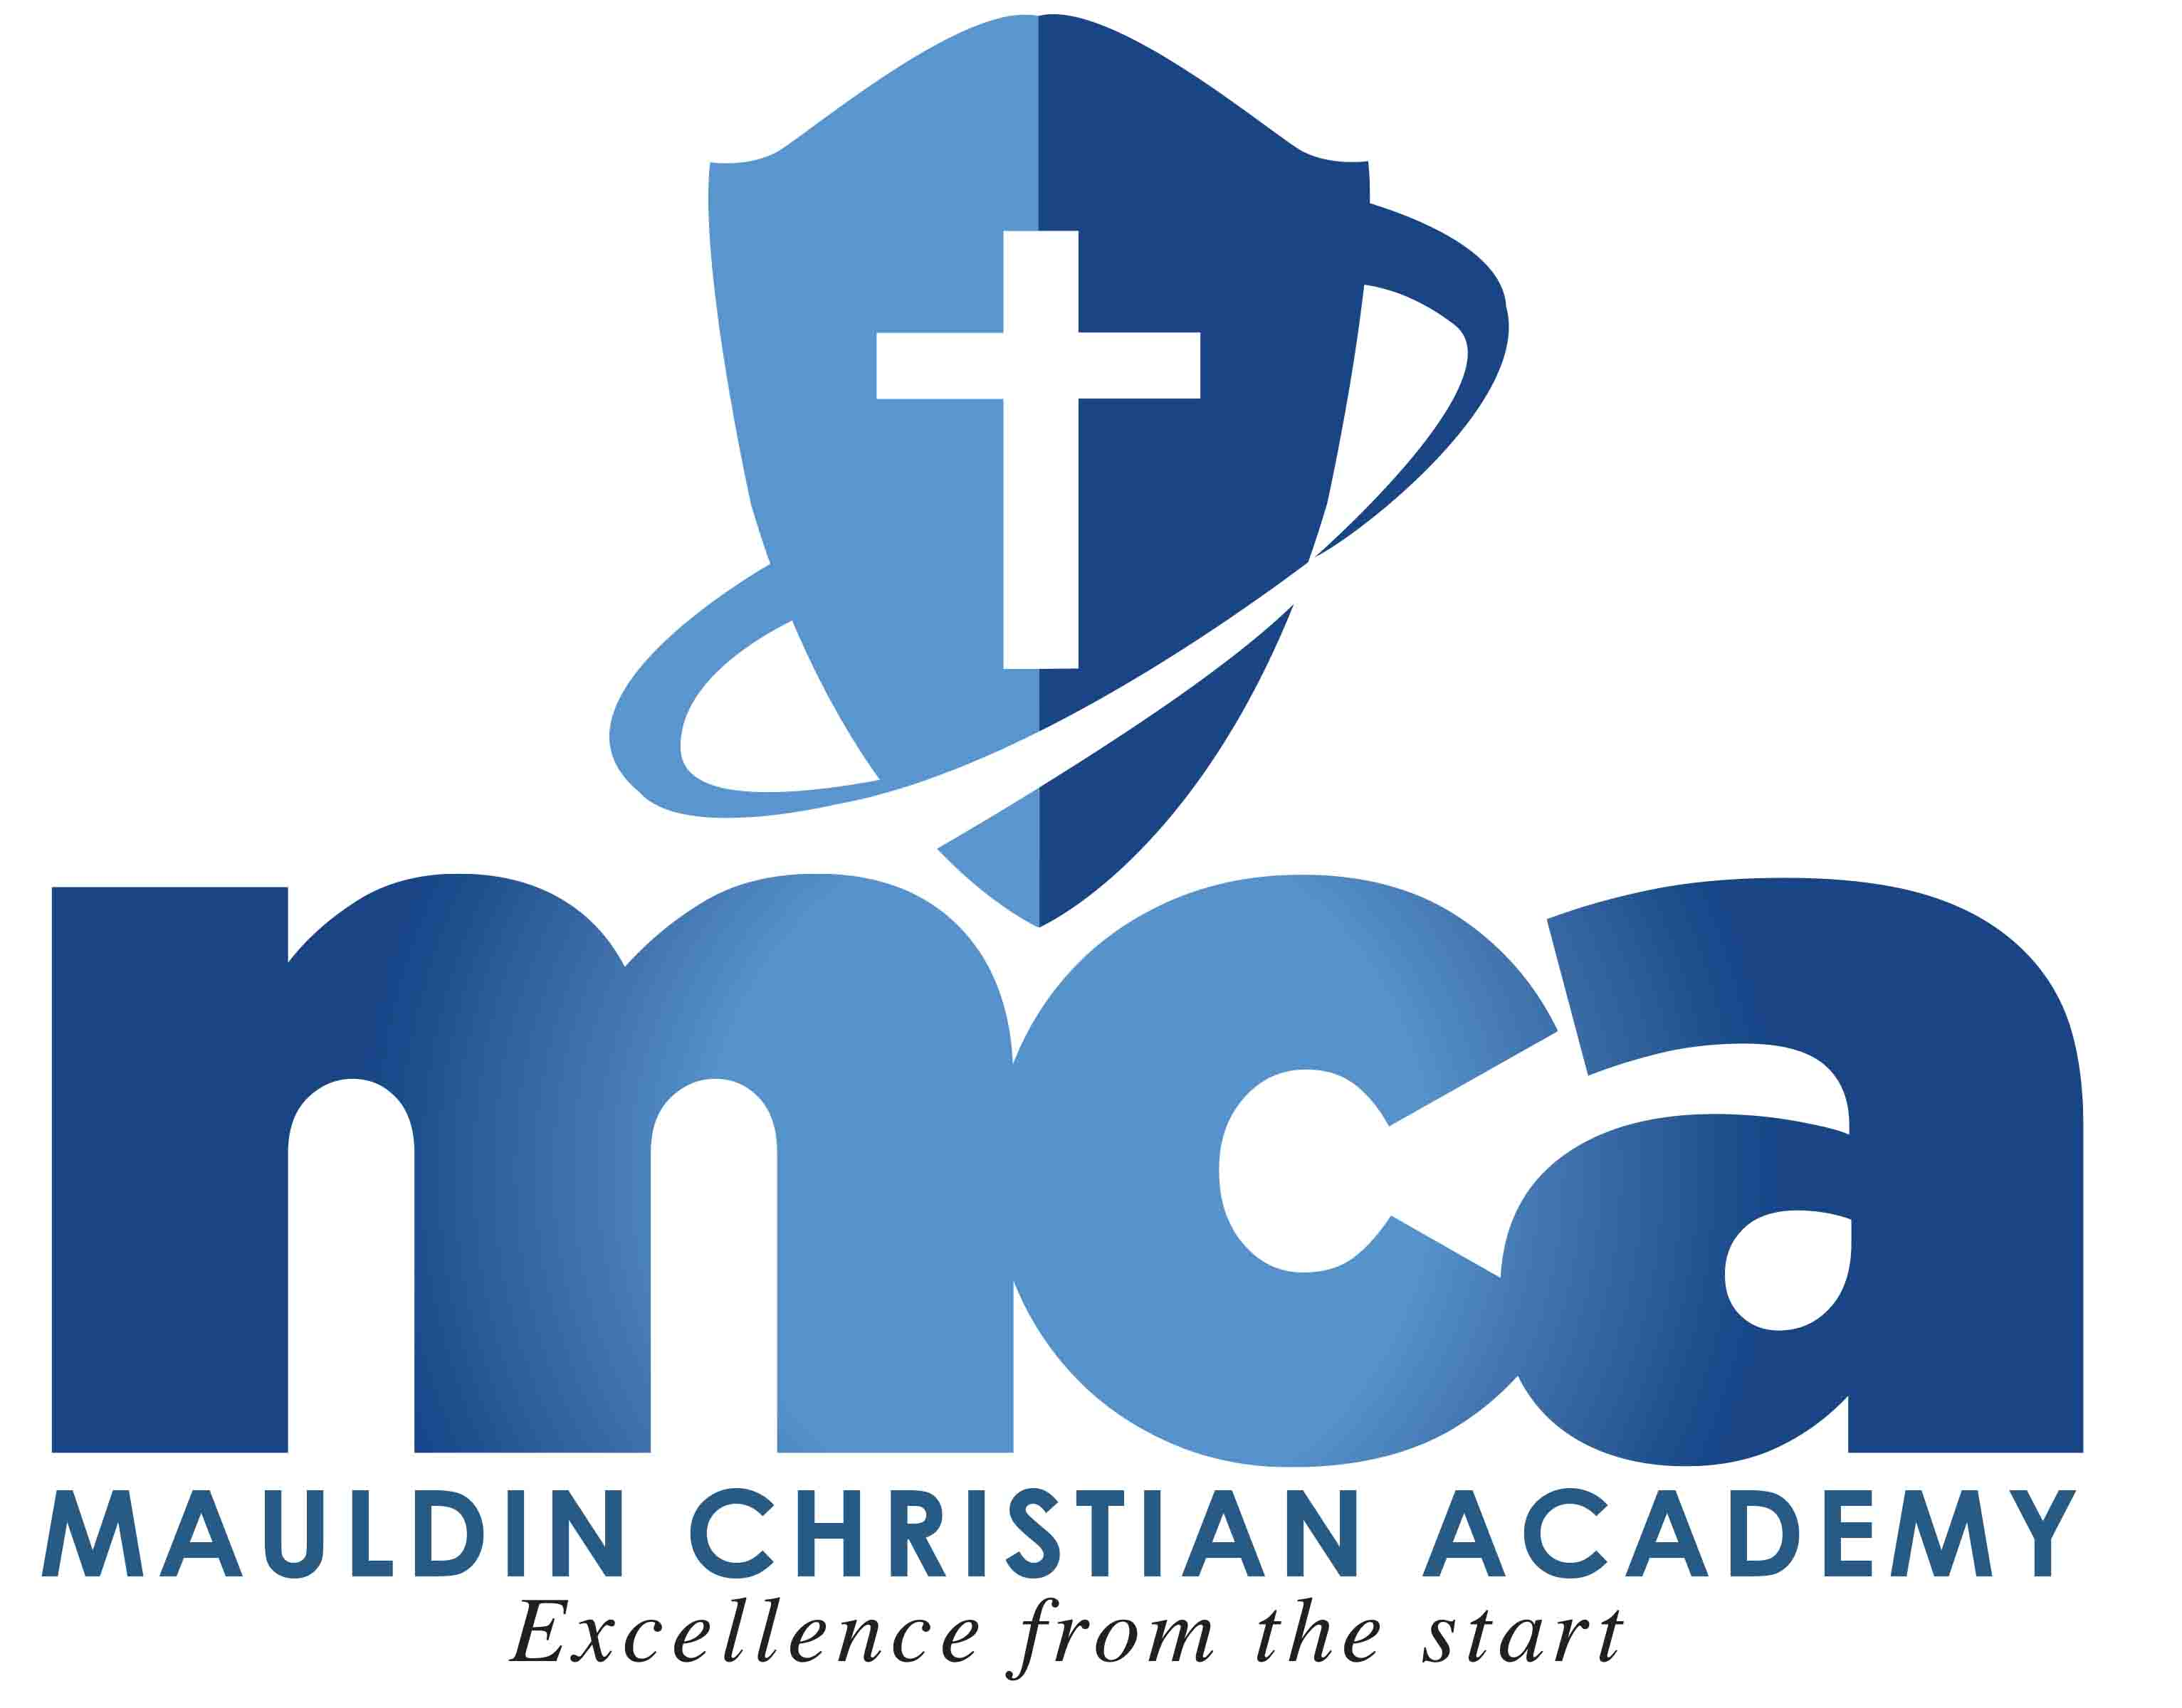
Mauldin Christian Academy
150 South Main Street
Mauldin SC 29662
864-288-1917 fax: 864-679-1623
Website: www.mauldinchristian.org

K5 Supply List 2018-2019 School Year
Mrs. Black and Mrs. Finotti

3 packs of Crayola 24 count crayons
1 pack of Crayola 10 count classic color, large tip markers
1 pack of Crayola 36 count colored pencils
1 twelve pack of #2 pencils (No novelty or recycled pencils)
1 pack of pink rectangular erasers
8 Elmer’s brand glue sticks
1 bottle of Elmer’s liquid glue
1 pair of blunt tip scissors
1 pack of white copy paper
3 boxes of Kleenex facial tissues
3 refill packs of baby wipes

Girls
1 pack of white cardstock
1 box of Ziploc quart size bags

Boys
1 pack of pastel or neon cardstock
1 box of Ziploc gallon size bags

All items will shared among the class, so please do not buy gender-specific items or label them. Thank you!

**It is highly recommended that Crayola brand products for crayons and markers be purchased due to their higher quality and longer lasting usage.

**You are encouraged to bring all supplies to Meet the Teacher Night on Thursday, August 16th at 6:30 p.m.**

